Successful events are often characterized by several key methods that contribute to their effectiveness. Firstly, clarity of objectives is paramount. Clearly defining the purpose and goals of the event provides a guiding framework for all planning efforts and ensures alignment across stakeholders. Whether it's to educate, entertain, inspire, or fundraise, having well-defined objectives helps focus resources, shape the event experience, and measure success.

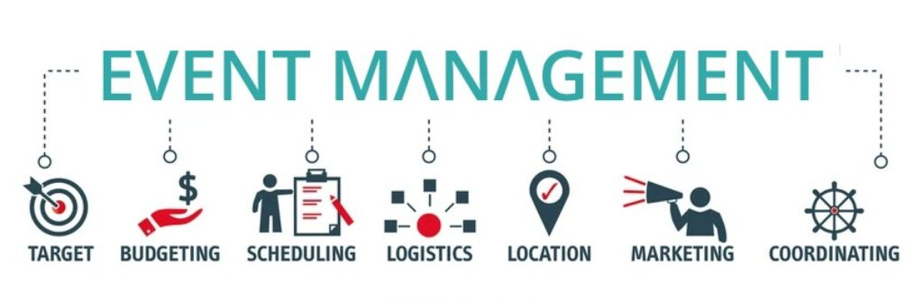

Secondly, understanding and catering to the needs of the target audience is essential. By conducting thorough research and analysis, organizers can gain insights into the preferences, interests, and demographics of their audience. This enables them to tailor the event program, content, and promotional efforts to resonate with attendees, increasing engagement and satisfaction. Effective promotion through targeted marketing channels further enhances visibility and attracts the right participants, maximizing the impact of the event.

Lastly, attention to detail and seamless execution are critical for delivering a memorable event experience. Meticulous planning and coordination of logistics, including venue selection, catering, technology, and on-site support, ensure that everything runs smoothly on the day of the event. Creating an inclusive and welcoming atmosphere, facilitating networking opportunities, and providing avenues for feedback and evaluation further enhance attendee satisfaction and foster long-term relationships. By employing these methods and strategies, event organizers can increase the likelihood of success and create meaningful experiences that leave a lasting impression on participants.